CONFIGURE DHCP & INTER-VLAN ROUTING ON LAYER 3 SWITCH

DHCP Server + Inter-VLAN Routing using MultiLayer Switch

Inacio Andre

2024

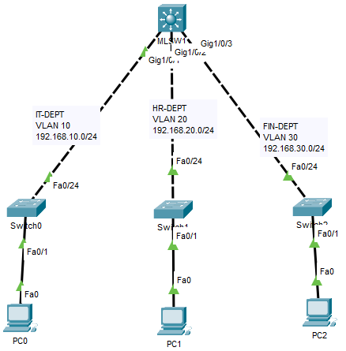

MLSW1

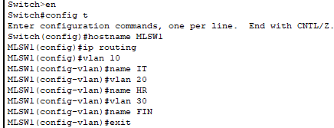

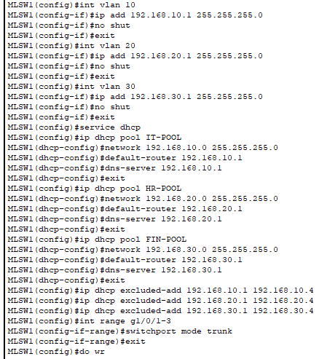

SW1

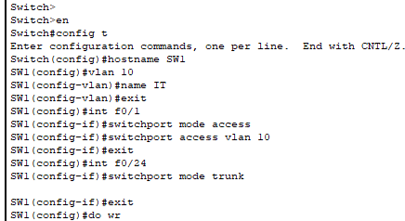

SW2

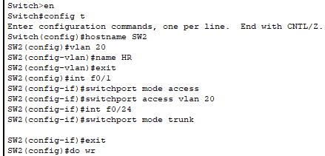

SW3

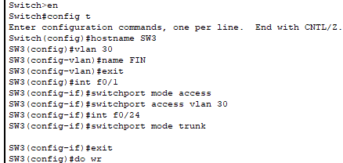

PC0

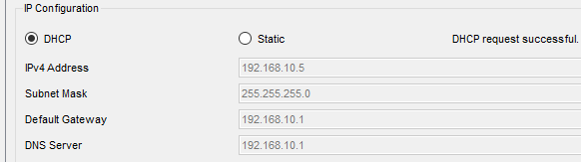

PC1

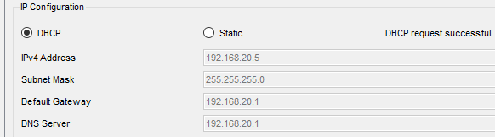

PC2

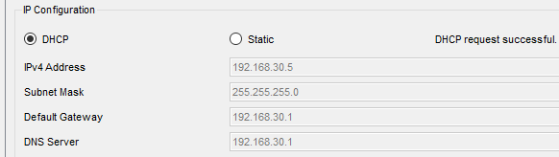

PC0 –T0-PC2

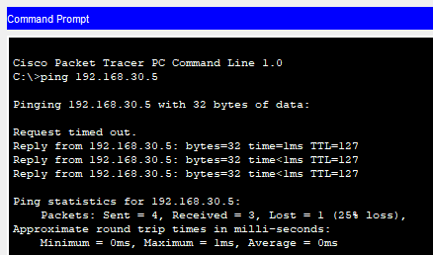

PC0-TO-PC1

